UNIT 6 HW

1. 



Do calculations manually. You may use computer output or the book for means and MSE. µ1, µ2, µ3, µ4, and µ5, are the mean scores in the none, amputee, crutches, hearing, and wheelchair groups respectively. Be careful when identifying ‘k’ here. This study is mentioned throughout Chapter 6 of Statistical Sleuth.

1. 



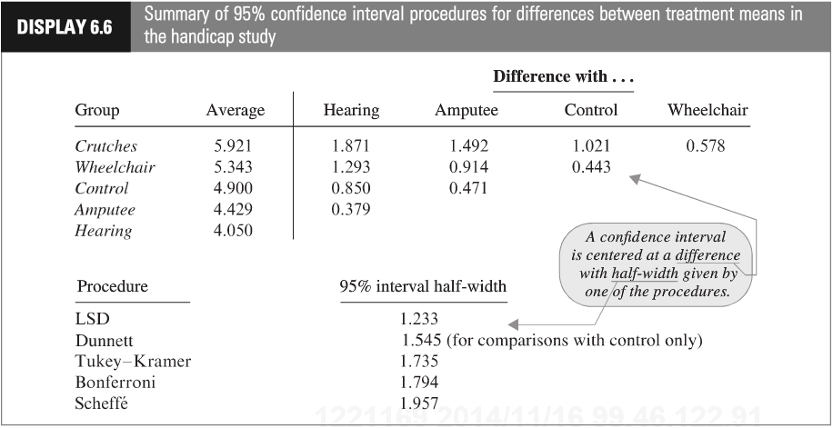

Show your work for this problem by simply copying the code and relevant output for each comparison. (Cut and paste your code and relevant output.) The half-width might be found directly from your output. If so, note where it is found. Do this for both R and SAS.

1. 

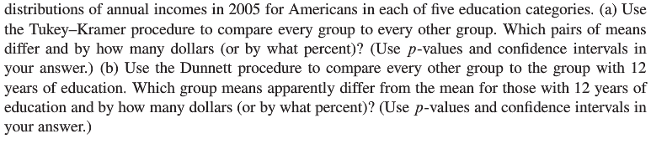

This question is obviously from the book, but assume you are starting this problem from scratch. Show all parts:

(1) Discussion of Assumptions (This could result in the inferences no longer being about the means. IF that happens, you should still compare the groups, just use the appropriate parameters when making inferences. Remember that you already did the work for addressing assumptions in prior homeworks.)

(2) Selection and Execution of Tests

(3) Interpretation and Conclusion.

In short, perform a complete analysis like you usually do. Provide and interpret all the confidence intervals that suggest a significant difference in incomes; provide your SAS and R code as well. (Generate your statistics using both softwares.)

**Finally, you should first test to see if any of the groups are different before you consider pairwise comparisons.**